Designing an app

Produced by Cristofer H

Table of context

**Introduction** **2**

**Design & Technical** **3**

**Client Requirements & Justification** **3**

**Visual Prototypes** **3**

**Technical Documentation** **3**

**Legal & Ethical Considerations** **3**

**Feedback** **4**

**Responses & Improvement** **4**

**Optimisation & Justification** **4**

**Testing Plan** **4**

**Evaluation** **5**

# Introduction

The mobile application is for an educational charity to help young children develop their arithmetic mathematical skills by providing them with an application with questions that the children have to answer a series of random math questions. This will help them develop their arithmetic skills over time and the program will assess their skills and time and keep it stored. This will allow for progressive feedback and ensure that the client can learn from the user and where they struggle the most to offer better services.

# 

# Design & Technical

Client Requirements & Justification

Client requirement will show the given obligation set out from the client that will be required to be added to the program, this will be the default hard coded features in the program and will come in order to satisfy the requirement as soon as possible and deliver what's demanded. The application will be designed for android users using the latest version of Android Pie. It won't use too much of the processing power of the android application; the application offers little processing requirement.

### *1. The app should run a game where the user has to answer a series of simple random arithmetic questions.*

The app should run a game where the user has to answer a series of simple random arithmetic questions and is amended to the requirements, this means every question will have to be randomly generated by a randomisation function. This prevents the event of the children misusing the application by typing the same answer over and over by memory which in effect doesn't help their math skills.

The equations used for this arithmetic are required to use addition, subtraction, multiplication and division. This makes it easier for the children to answer; we are only working on improving the fundamental arithmetic based skills.

The requirement suggests using round numbers from 1 and 12, this means this will help these children develop their time's tables all the way up to twelve. This means the last or maximum question with large numbers can only be 12 * 12 which is 144. This keeps it manageable and relatively easy and manageable to answer.

*"In maths, it says pupils should be introduced to the two, five and 10 times tables by year two - at the age of six and seven. Between the age of seven and eight, children should start to learn the three, four and eight times tables, the document says."*

*Sport, B., 2021. Nine-year-olds should recite times tables by heart, says Schools Minister. [online] The Telegraph. Available at: <*[*https://www.telegraph.co.uk/education/*](https://www.telegraph.co.uk/education/educationnews/11251221/Nine-year-olds-should-recite-times-tables-by-heart-says-Schools-Minister.html)*> [Accessed 23 April 2021].*

Using this data we can determine that the age of the target audience of this application would be kids around the ages of 9 - 12. This allows us to make extensive alterations to the design to better accommodate that age group.

### *2. Subtraction and division should not produce negative answers.*

Keeping to the requirements the application shouldn't provide any difficult arithmetic type questions by not only appropriating numbers from 0 to 12 for calculations but also not producing a negative output as answers. This will make the application easier to suit more of its demographic which would be children; making negative possible outcomes can make it too difficult for them, likely resulting in the users getting a piece of paper and working out the answer. Which completely defeats the usage of an application that is used to test and examine your mental math skills.

This will mean while generating the answers there will need to be quality control of the output and ensure the outcome isn't less than zero. This means as an example if an answer shown in the next question is -2 the program will be required to generate another question that will have the answer to be more than equal to zero ensuring this requirement is mandatorily met.

### *3. Each game should have 10 questions and the app should keep track of the score.*

The requirement states that each level should have 10 questions per stage or levels, per threshold. This means that the game should at least provide 10 generated questions within all levels, per threshold. The way the application will delineate the level will be the following:

The first level known as level 0 will provide 10 basic arithmetic questions with a no set limit timer as the requirement requests, this level will be an easy based level and will get the users used to the game and get a feeling for the types of questions they will be challenged to answer.

Level 1 will be the first-ever level to start to challenge the user by adding a timer. The timer will be 20 seconds per question so it will provide a plethora of time for the user so it should still be straightforward to answer although the time is now limited; the user has 20 seconds to answer the question. If the user fails to answer the question before the timer hits zero it will automatically skip the user to the next question.

Lastly, Level 2 is the final level of the examination of the application of the user's feedback. This will offer relatively more complex arithmetic based questions with an even smaller time frame to answer in. The user will have up to 10 seconds to answer the difficult questions. After the level is complete the user's information will be kept and stored in the storage of the application.

This data can then be further looked at and diagnosed with performance scans to determine what the output of the user's result was during the test or "gameplay". This will indicate to the parent or career of the child playing this game what their mathematical capabilities are. The application will factor in the levels, level 0 - 1 being fundamental. This suggests that levels 0 will be the most important feedback as it will offer the most basic fundamental math questions such as addition and subtraction.

Level 1 will consist of easy division and multiplication. This will be more advanced compared to level 0 but it will harvest the information of the user about their multiplication and division skills. Then level 2 will offer complex numbers with equations and this will show how advanced the users are dealing with multiplication, addition, division, multiplication on large numbers.

### ***Grading Hierarchy***

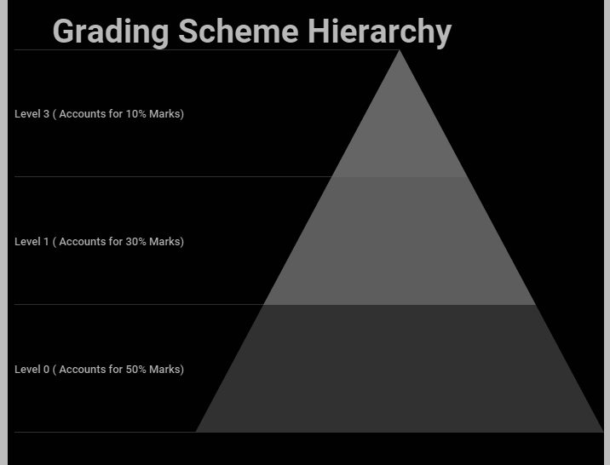

# 

# 

# 

# 

# 

# 

# 

Fondly enough as established 50% of the grading will account for 50% as this stage is the easiest as it requires the important fundamental mathematical skill. Level 1 will begin to offer more advanced equations such as multiplication and division although again it is fairly easy and shouldn't be difficult. Level 1 shows that you know multiplication and division which is why it offers 30% of the grade. The 10% will be the most advanced question and will offer low marks because the application is only to assess the fundamentals and nothing more.

The grading or track record is designed to be fair, not who can get the "most marks". This means that the application tests you on your knowledge rather than guessing and times you on it as well. Most of the people using this application will have to at least get level 0 and partially level 1 right before getting a pass showing they understand these fundamental components. However, those people who excel at level 3 will get the very few marks required to achieve a high grade in the marking grid.

### *4. The app should include suitable graphics and sounds*

To ensure the application better suits its target audience as a requirement, the user experience would appeal to a younger audience. This would mean by providing a colourful interface that's kept minimalistic would be optimal. This means that not only will the user interface be easy to navigate and operate but it also offers extensive features to meet the requirement making the application fulfil its primary purpose. By providing a simple and minimalistic interface it reduces the chances drastically of users not knowing how to use the application.

Secondly, the colours will have to suit its target audience meaning the main bias of the colour election will have to be bright, although since the application isn't primarily being targeted to solely male or female this means that it will have to remain gender-neutral.

Since the anticipated target audience of the kids utilising the application will be around key stage 2 (7 - 11 years of age.) according to sciencing.com

*"Children tend to be attracted to the bright block colors of the color wheel rather than pastels or muted blends. Primary colors red, yellow and blue, and secondary colors green, orange and purple, are more appealing than light shades of pink and beige or neutral shades of gray and brown.."*

*Sciencing. 2021. How Do Bright Colors Appeal to Kids?. [online] Available at: <*[*https://sciencing.com*](https://sciencing.com/do-bright-colors-appeal-kids-5476948.htm)*l> [Accessed 28 April 2021].*

This means that the colour pallet will have to include either red, yellow or blue. Since the app will primarily have a clean white background with plenty of white space the buttons highlighted can be corrected to the colours that will appeal to the target audience. This means that the audience will be more inclined to select the button due to its colour, this can increase the engagement and performance of the clients when engaging with the software.

Areas such as answers, the start button will have these highlighted to ensure the whole process of examining the target audience can be more natural. Sound effects will also be included such as a tick once a question has been answered however this will have to be thought heavily as it can become bothersome promptly if the sound effects are awful.

# Visual Prototypes

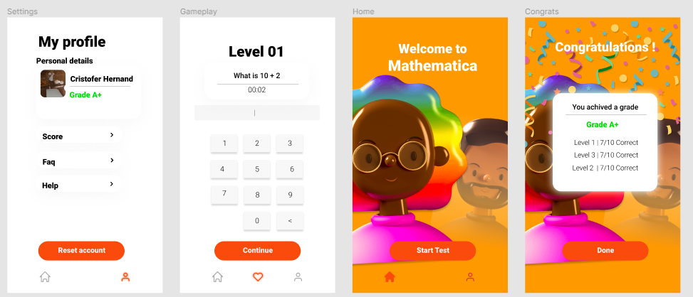

*Hernandez, C., 2021. FIGMA UI Design. [image] Available at: <*[*https://www.figma.com*](https://www.figma.com/file/RcWSb5iGfuyEgQ7fqVebKe/Untitled?node-id=0%3A1)*> [Accessed 28 April 2021].*

I have used FIGMA to create my prototype for the creation of the application. The application contains a simplistic minimalistic user interface that makes the application easy to use and move around. There will only be 2 separate tabs the user can navigate to.

The user can go to their accounts and look at their grade, track record, information, settings. The other is the home tab which will only have one button appealing to the user to "start test".

**Consistency** - The buttons will always be in the same coordinates and will always be present on each page as continue, start test, reset account, done. The application will also have the same font throughout which is Roboto. Again ensuring the requirement suitable graphics is met.

**White Space** - The application will have a clean minimalistic look so it will provide the most white space, this means that the application will be easy to navigate as the buttons are highlighted clearly and there is plenty of space to ensure there is suitable graphics.

**Reversal actions** - There will be no prior reversal actions in the application although it will provide tabs that the user can navigate instead of again keep it simple.

**Colour** - The application has the same colour interface pallet throughout and has a similar layout on each page. Orange will represent a call to action while grey will represent an option that can be selected. The colour better suits the target audience for the application as explained in the requirements, ensuring the demand of suitable graphics is met.

The interfaces in the application will be the Home page, Accounts, Examination, Congrats. This interface will be similar to each other and have design crossovers.

**My profile** - This will display the account user and the grade they have achieved after taking the examination meeting the necessity of keeping track of the score.

**Congratulations** - Will show how they did and the overall achieved grade, this will show them their stats when using the application. Meeting the requirement of keeping the track score and informing the user about this.

**Accounts** - will offer them to read their data and also reset their account if they wish, this means they can also keep track of their records using this part interface.

**Home** - this offers nothing but an enticing button that when clicked it starts the examination process this essentially meets the demands of making the quiz.

**Examination** - Will provide the question and the tools the user needs to get the question right. It can't be accessible, the only way to access it is through the start test button on the home page. The build of the UI is like a calculator that will show buttons laid out like one used for typing in the numbers rather than the phone standard keyboard. This keeps it clean and minimal keeping the graphics suitable. It will show the question and the timer on the top making it visible. As the timer goes to less than 5 it will turn red to alert the user.

# Technical Documentation

This is the question generation algorithm flowchart. This is an example of the first level; level 0 will have simple addition and subtraction questions and will generate numbers while keeping in check of the answer not being negative. In summary this flowchart will help build the program fundamental framework to meet the requirements.

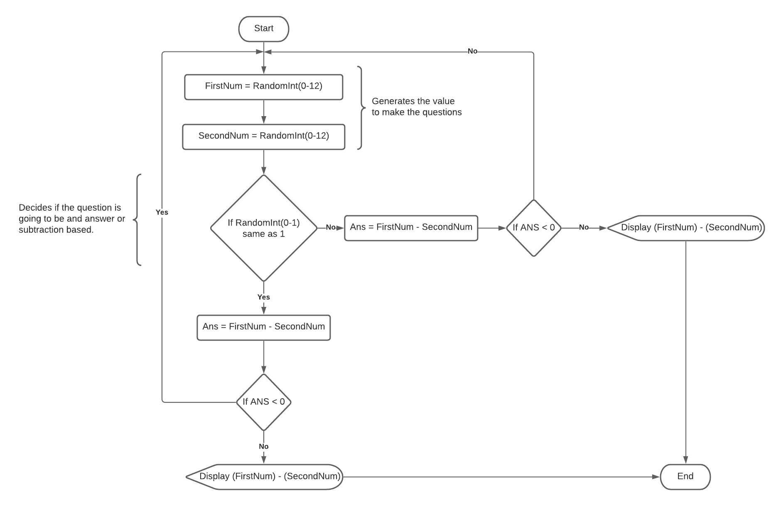

# 

# Legal & Ethical Considerations

When building the application the software won't require as much legal attention as it's a harmless mathematical application that tests the users arithmetic skills and grades them, for ethical consideration, there won't be much as defined before it's an inoffensive math application.

**Legal**

For legal consideration their user's data will have to be stored and kept safe within the application, the data will only retain the user's grade and status such as how many questions they had correct at what stage and perhaps on what they can improve on. The user will have full access and control over their own information, the user can choose to reset their account which will wipe the information from the system. This complies with the Data Protection Act 2018 to void any legal lawsuits.

The data that the application will harvest from the user will be their name, profile picture (optional), assessed grade.

The sound effects that will be used for the application will be taken from a royalty-free website and credits will be promoted on the about or settings page. The website hasn't yet been chosen however I could most likely take samples from the website: https://artlist.io/ which is a royalty free music platform for content developers.

*"You can use them freely in your products & projects - print or digital, commercial or otherwise. However, you can't sell the fonts on their own."*

*Google Fonts. 2021. Google Fonts. [online] Available at: <*[*https://fonts.google.com/specimen/Roboto*](https://fonts.google.com/specimen/Roboto#abou)*t> [Accessed 28 April 2021].*

The font being used for the application will be Roboto, the font is allowed for free commercial usage as long as the font isn't being sold online.

**Ethical**

To ensure the application doesn't make anyone feel bad for who gets assessed, the application will always congratulate you after taking an exam and provide you with your grade even if it's an unfortunate grade.

# 

# Feedback

Responses & Improvement

I have sent a forum for all surveyors to see and read so I can get some external feedback on the design of the application and apply any initial adjustments to ensure the requirements are individually met.

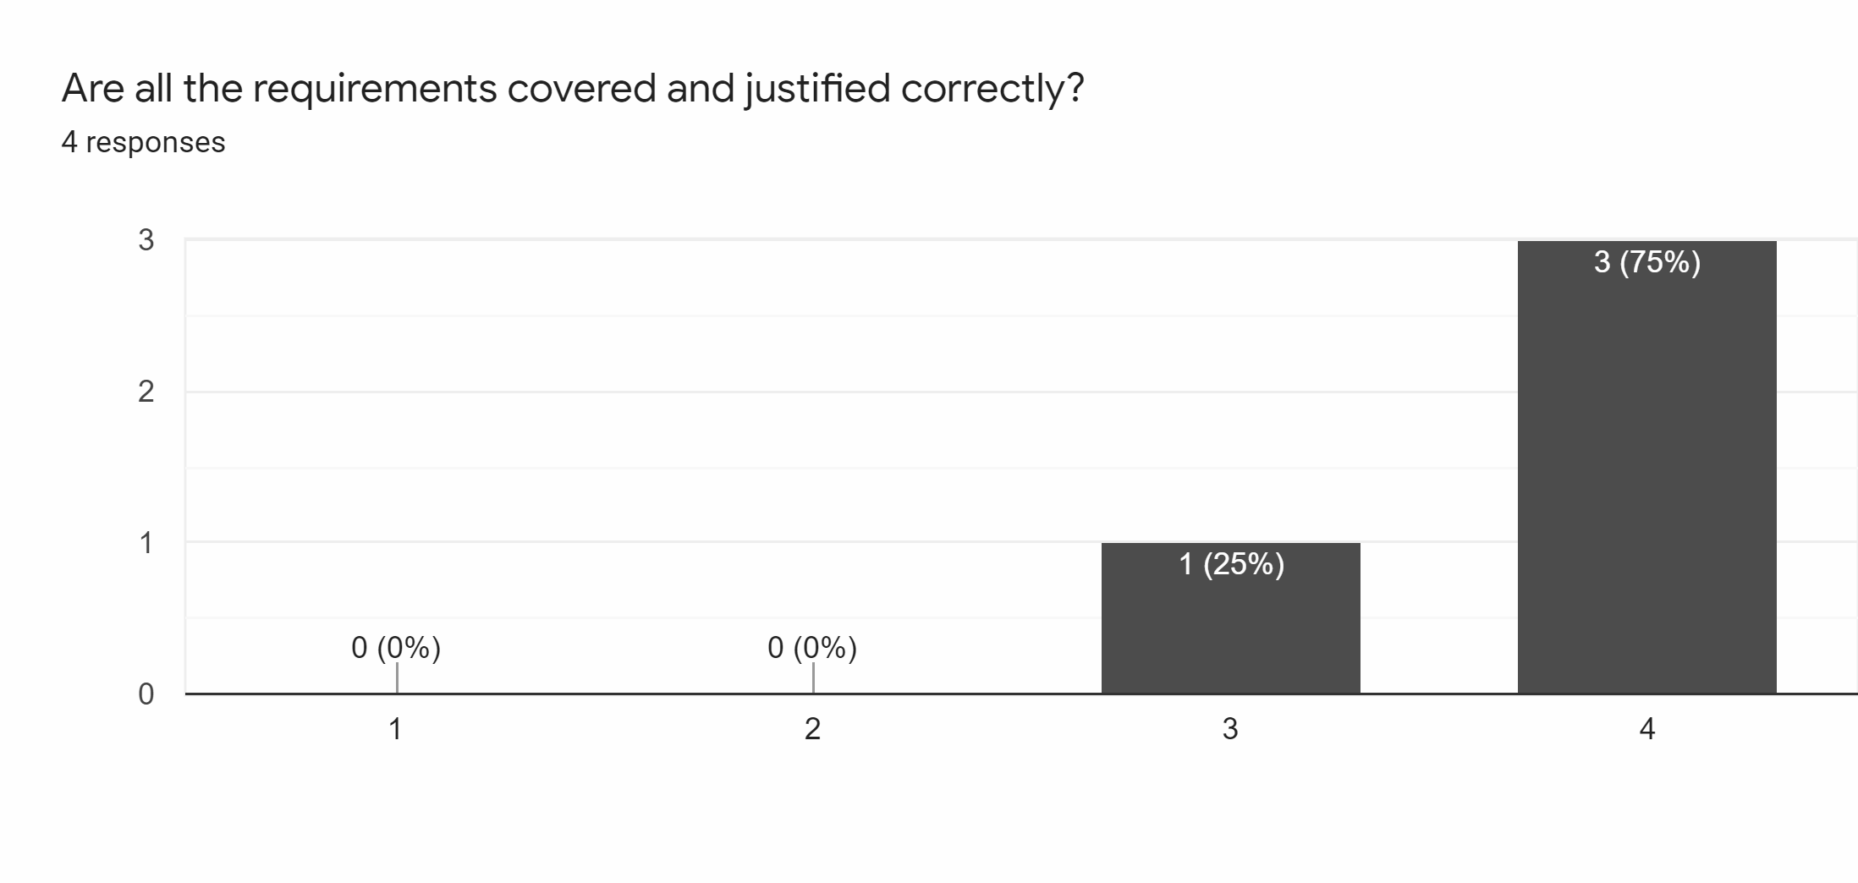According to most the requirements are mainly covered and justified correctly. This means that all aspects of the application requirements are covered.

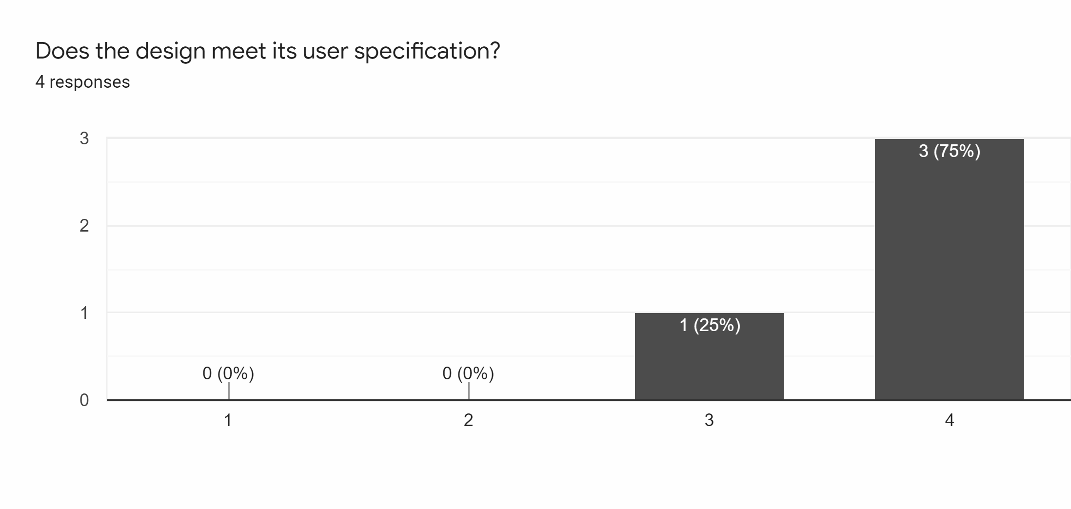Following up with the previous question I inquired if it met the user specification, 75% of them fully agree and only 25% partially agree this means that the specifications were mainly or fully met to an extent.

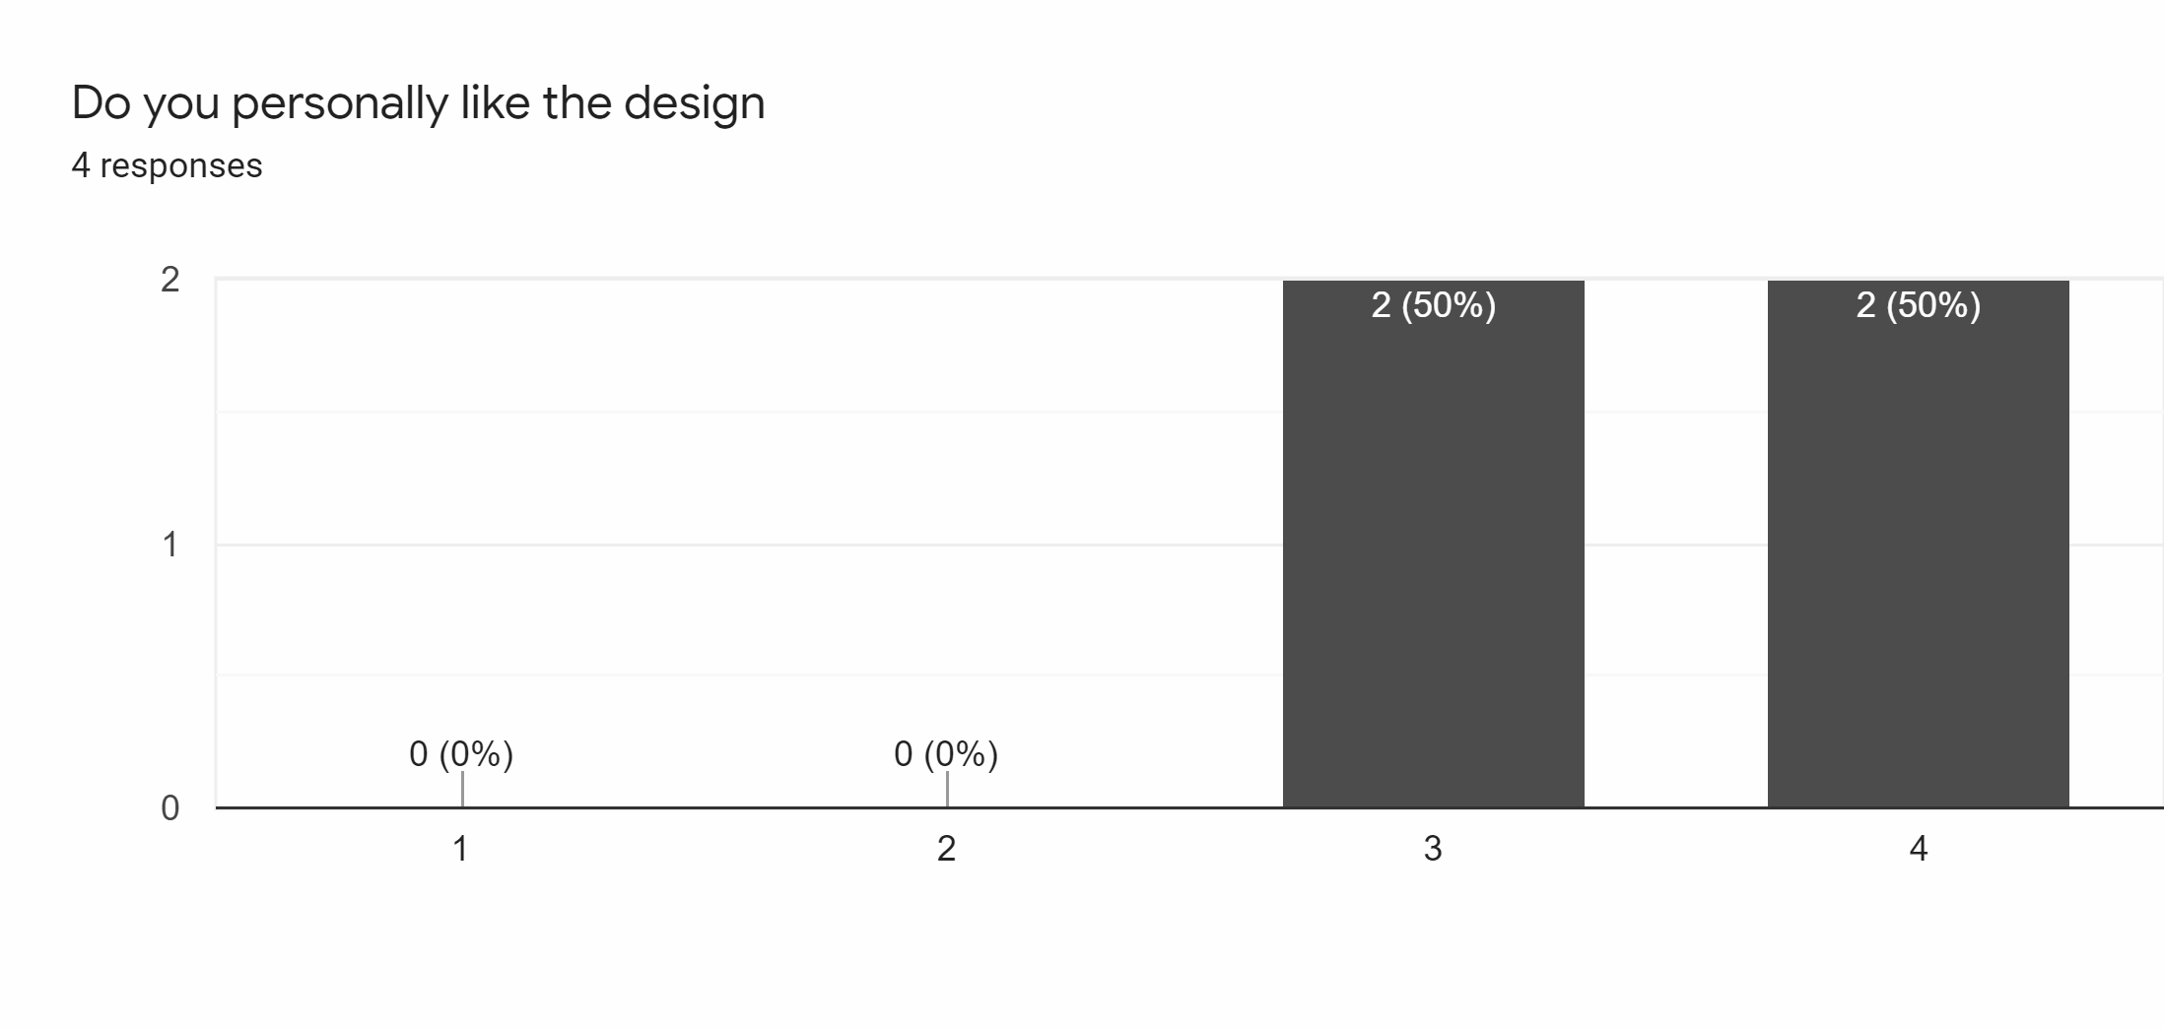Most liked the design although from the feedback only 50% thought it was better than average whereas the other 50% personally liked it, this means there are some tweaks required for the application to be done.

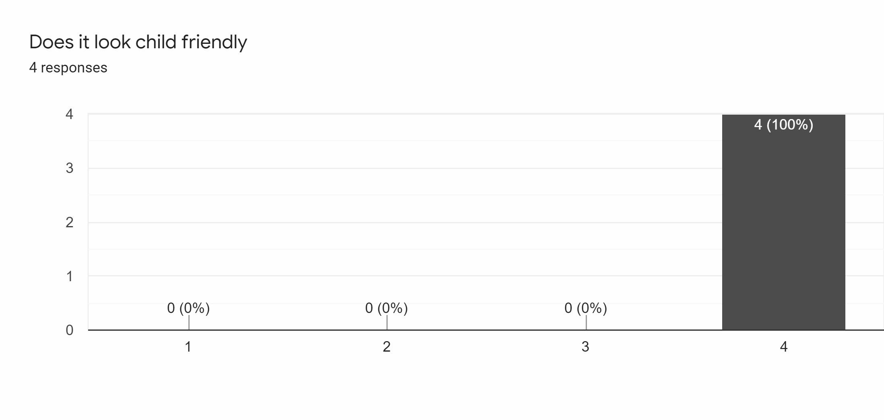Most importantly to give a non bias approach I also asked if the design looked child friendly, most agreed this alone is enough and substantial evidence that application already suits its target audience.

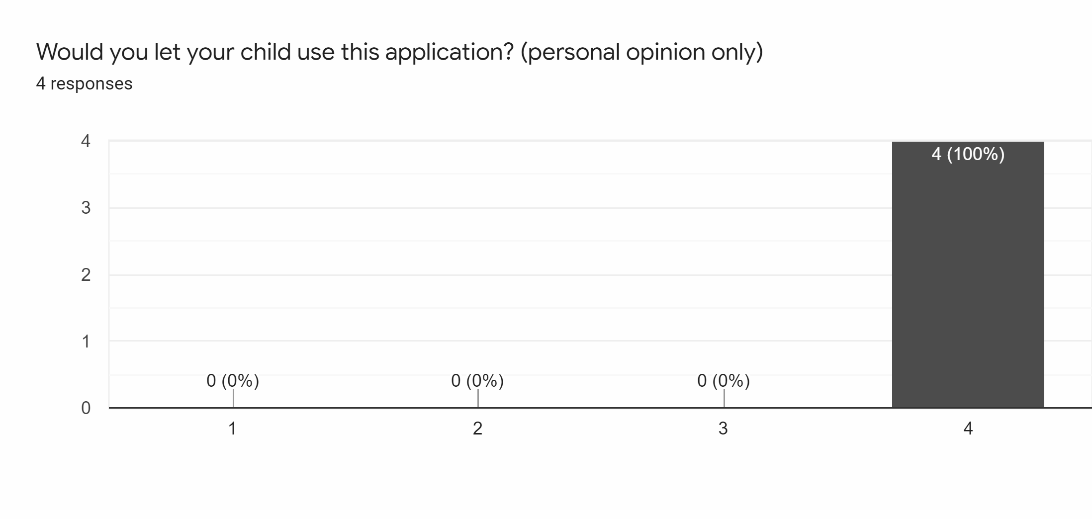Most would consent their child to use the application this means that the application is in fact child-friendly and shows parents are willing to let their child use the application expanding it to potential users.

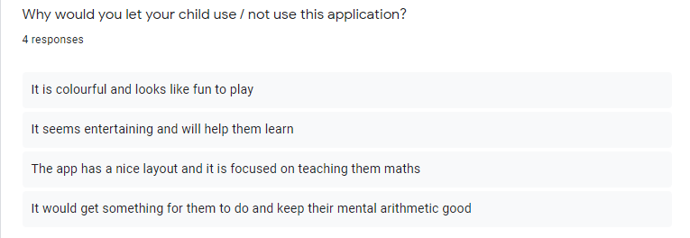To concrete the evidence I inquired their reason for it there was a diverse set of answers however there for generalisation there was 50% that said the general nature of the application was good. Where as others like the user interface.

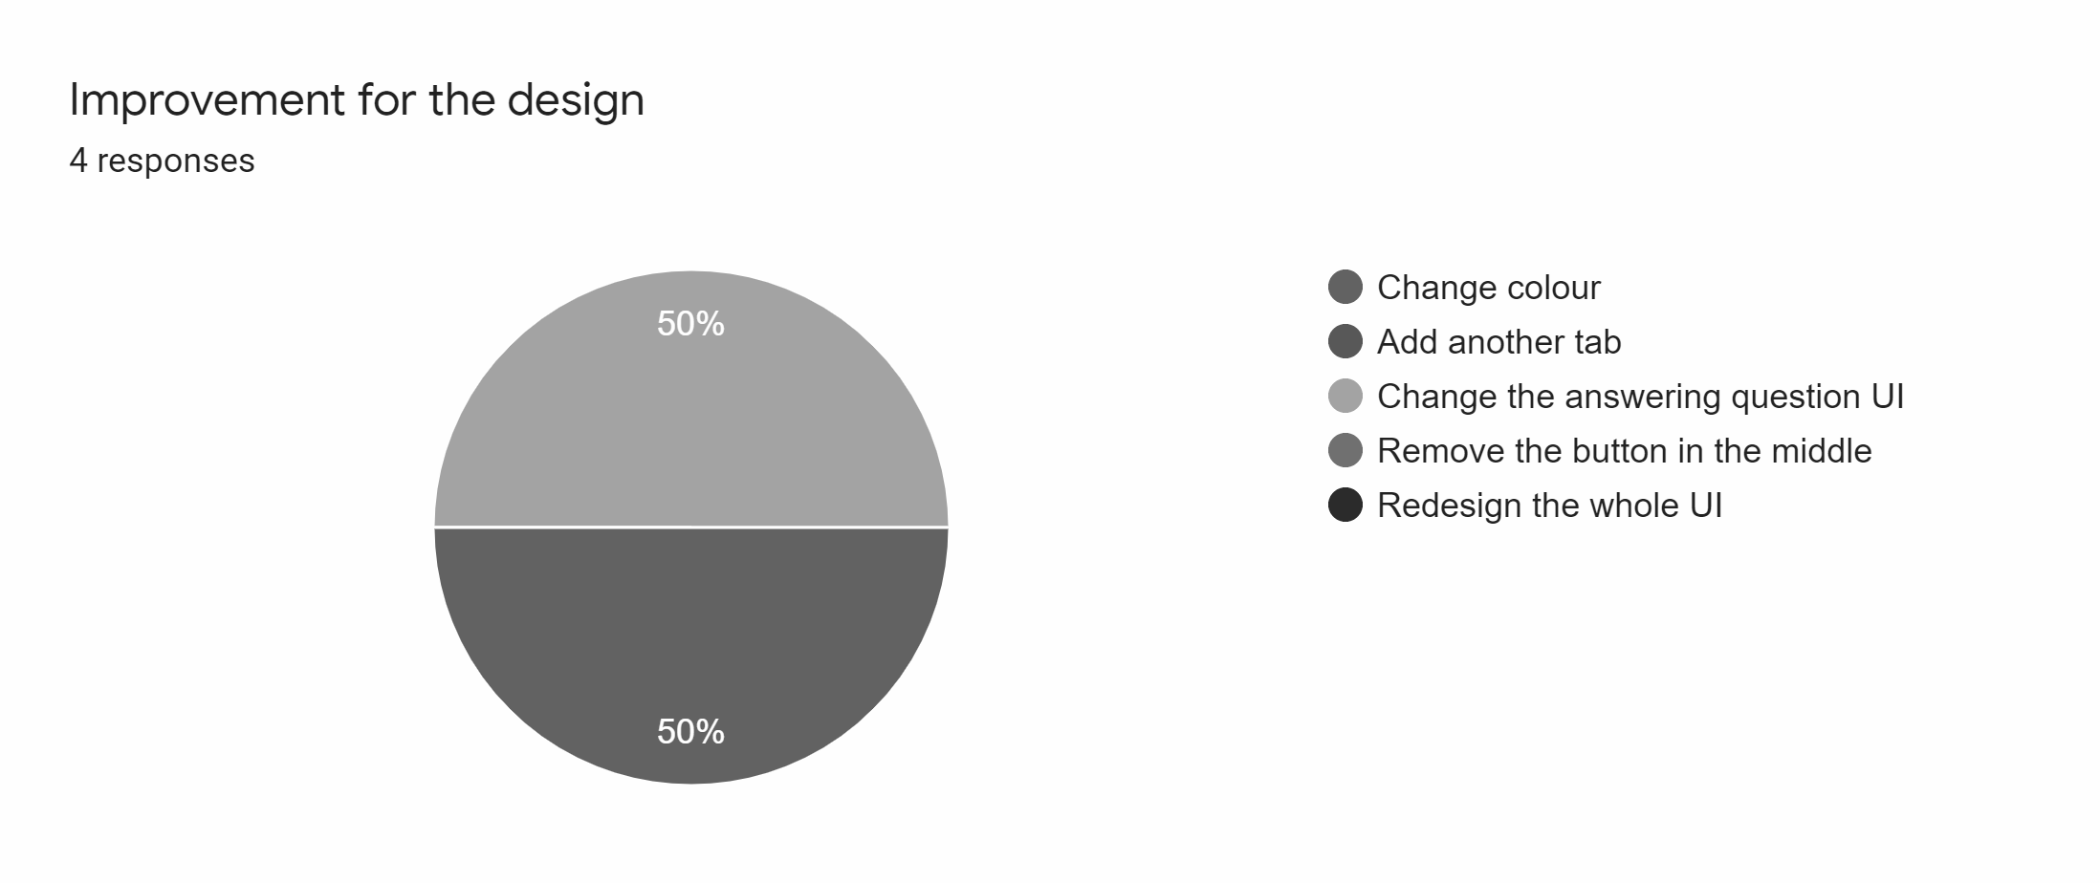For adjustments and development, 50% of the advocates preferred changing the answering UI whereas the other 50% would prefer a colour redesign.

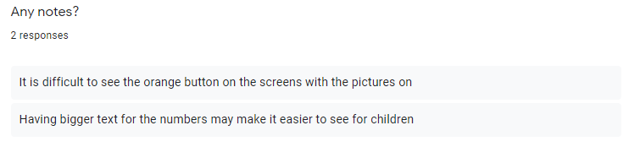On the notes, someone declared that the text is too small whereas the other said the colour UI requires to look different to ensure it stands out. In summary, surveying this we have got enough data to work on and improve the application to further improve and optimise the design of it even more.

# Optimisation & Justification

Using the data from the survey I have resigned the application to better suit the user's needs and requirements from external opinions of the application to deliver a non-bias approach.

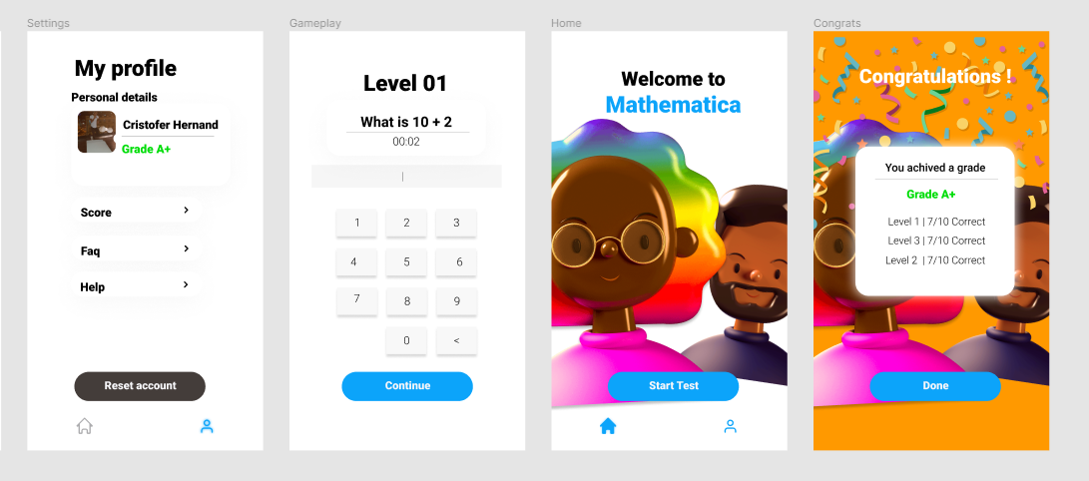

**UI Updates - Colour scheme**

Working on the first set of improvements I have worked on the user interface and designed the colour scheme to make it more appropriate. Following the studies of what colour children tend to select seen on the requirement justification part. I have used blue as the standard colour for selecting anything. This makes the button stand out and looks more pleasing to the colour scheme compared to the orange. In the profile, I have also changed the button to grey to ensure this stands out to the rest and add volume to the button; this button if clicked would reset the user score.

The background was changed to white to give it more of a cleaner outlook as well, although on the congratulations page the user interface of the orange background was kept; the reason for this is to make the message board be more visible and orange portray a sense of celebration and happiness relative to its similar colour yellow.

**UI Updates - Text enlargement**

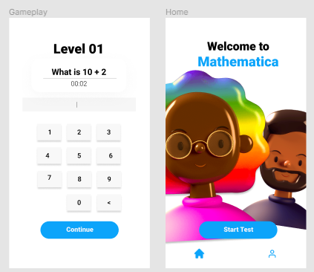

Previous reviews of the application advocated that the question font was too small so I decided to enlarge the text to make it more visible and the buttons were also enlarged to make it more readable for the users that can't read the small text as this could disadvantage them when using the application.

# Testing Plan

|  |  |  |
| --- | --- | --- |
| Test Name | Description | Expected result |
| Question answering | Type an answer and click on continue. | When the user answers a question they can go to the next and in the background, the application will begin marking and assessing his input. |
| Reset application | When on the settings panel or page the user can click the reset button. | The application will go blank (fade perhaps) and then the score board and name resets. |
| Change screens | When clicked on the button inside the lower tab it will change the interface. | Should be able to change the UI and return back to the previous page. |
| Update grade | Once the user clicks done on the congratulation screen the software will update their current grade to the latest one. | The current grade on the settings page will be replaced. |
| Sound effects | When clicked on any part of the application a sound effect will play to make the application feel interactive. | When a button is clicked a sound effect will play from an mp3 library folder. |

# 

# Evaluation

In summary, the application known as Mathematica has been evaluated and expanded to the most detail with the planning; the next stages within the application will be implementing these ideas to an actual framework. The requirements that have been specifically delineated have been met to the fullest extent. The review has also made additional adjustments and requirements to my design which I have fully adapted and embraced to ensure there is an external party being met included with the original requirements to ensure that this application for android users can be delivered properly.